Water Quality
Chapter 14

- Importance of Water for life:

- Water Issues-
- Quantity

- Quality

- Water Terms to Know
  - Evaporation=

  - Humidity=

  - Condensation=

  - Solution=

  - Suspension=

  - Fresh water=

  - Salt Water=

  - Brackish Water=

  - Hard water=

  - Soft Water=

  - Polluted Water=

  - Purified Water=

- Purifying water - Processes
  - Distilation
  - Filtration
  - Chemical Absorption
  - Biological oxidation
  - Disinfection

- Water Pollution =

  - Point source pollution

  - Nonpoint sources –

- Human Waste Water concerns:

A. DO =

BOD =

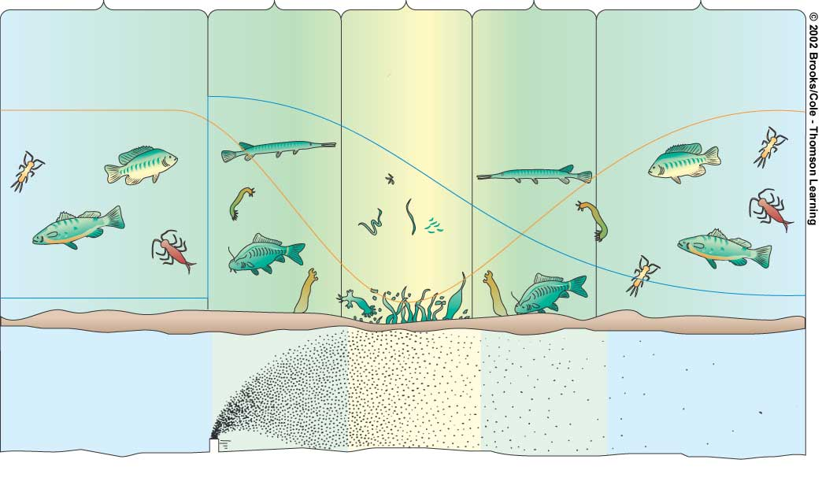
Oxygen Sag Curve -
Clean Zone
Septic Zone
Recovery Zone
Clean Zone
Normal clean water organisms
(Trout, perch, bass,
mayfly, stonefly)
Trash fish
(carp, gar,
Leeches)
Fish absent, fungi,
Sludge worms,
bacteria
(anaerobic)
Trash fish
(carp, gar,
Leeches)
Normal clean water organisms
(Trout, perch, bass,
mayfly, stonefly)
8 ppm
Dissolved oxygen
Oxygen sag
2 ppm
8 ppm

B. Eutrophication

Dead Zone =

- Disease and waste water

Water Treatment for sewage

  - Septic Tanks

  - sewage Treatment plants
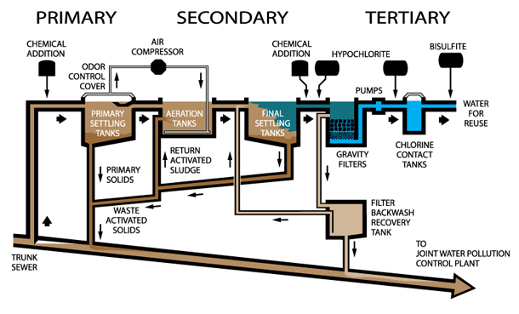

  - Manure Lagoon-
- Other pollutants
  - Lead

  - Arsenic

  - Mercury

  - Acids
    - Acid Rain

    - Acid Mine Drainage

  - Synthetic Compounds
    - Pesticides

    - Pharmaceuticals and hormones

    - Military compounds

    - Industrial Compounds

- Oil spills and Oil pollution

- Other types of water pollution:
  - Solid waste

  - Sediments

  - Thermal

  - Noise

- Preventing Water Pollution
Nonpoint sources | Point Sources

- Water Pollutants
Pollutant | Source | Effects

- Bottled Water

- Water Legislation

Year | Act or Bill | What it does:

